SALESBOT QNA ASSISTANT
30 June 2025
15:59

- Problem Statement
Sales managers often struggle to explore and interpret sales data efficiently due to the technical complexity of SQL queries, limited self-service analytics tools, and the absence of interactive dashboards that adapt to natural language queries. This limits timely insights and hinders data-driven decision-making across teams.

- Objective
To develop an AI-powered chatbot that allows users to:
- Ask natural language questions about their sales data
- Automatically convert these questions into executable SQL queries
- Visualize the results using appropriate charts
- Generate human-readable insights and summaries
- Tools & Technologies Used

Category | Tools/Technologies
Frontend | Streamlit, Plotly
Backend | SQLite, Pandas
AI/LLM | Azure OpenAI (AzureChatOpenAI via LangChain), Llama 3.3 using GROQ API
Prompting | Custom SQL prompt templates, Insight prompts
Storage | Parquet, SQLite DB (sales_data.db)
4. Methodology
- Data Setup
  - Sales data is stored in Parquet format and loaded into an SQLite database (sales_data.db).
  - The schema is extracted dynamically for accurate LLM prompting.
- Natural Language to SQL Conversion
  - User question is passed to Azure OpenAI with a detailed SQL prompt.
  - Prompt logic handles:
  - Brand, branch, and time filtering
  - Case-insensitive matching
  - Grouping and aggregation (monthly/daily)
  - Syntax-safe SQLite generation
- Query Execution & Result Handling
  - SQL query is executed on the database using pandas.read_sql_query.
  - If applicable, results are plotted using Plotly (line, bar, pie, etc.)
- Insight Generation
  - LLM generates insights based on:
  - Raw SQL output
  - Charted/aggregated trends
  - Prompts guide the model to give trend analysis, brand comparison, or branch performance commentary.
- Interactive Chat Experience
  - History of user questions, SQL, plots, and insights is saved.
  - Users can review, rerun, or compare across chat sessions in the sidebar.
  - "Show SQL" and "Show table" options enable transparency and trust.

- Results & Features
  - Zero SQL knowledge required: Users can ask questions like “Compare Indomie sales in North vs South” or “Show monthly trend for Addmie”.
  - Dynamic Visualizations: Time-series, comparison, and generic plots are auto-selected and rendered.
  - LLM-Powered Insights: GPT-based insights make data more actionable and understandable for non-technical users.
  - Conversation History: Maintains per-chat memory with contextual recall and review.
  - Schema-aware SQL: SQL queries are tightly aligned with real schema, preventing invalid queries

Workflow

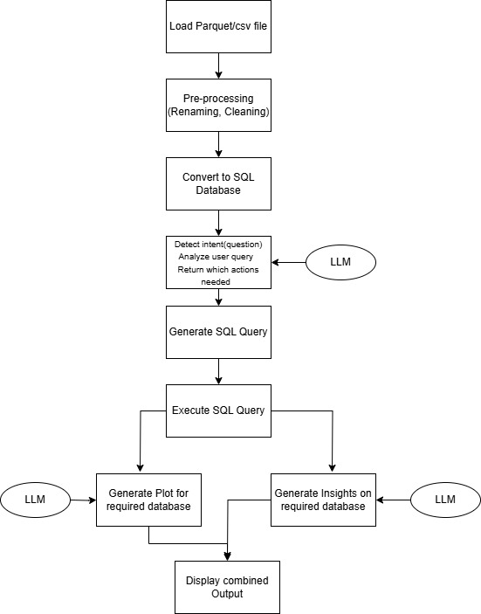

excel-chatbot and final_sql are the folders for this approach.
Only plotting capabilities is different in these folders.
Main file in excel-chatbot is cb.py and main file in final_sql is appc.py

Forecasting
01 July 2025
10:31

I have created dataframe by grouping data week wise and then applied Holt-Winters model to it.

For time series forecasting on any specific brand's weekly sales data we use the Holt-Winters Exponential Smoothing method.

It begins by loading and preprocessing the sales data, converting weekly date ranges to start dates, and handling outliers using the IQR method with linear interpolation.

After preparing the cleaned data, it conducts a grid search over different seasonal types (add, mul) and seasonal periods (52 for yearly, 12 for monthly) to find the best model based on Mean Absolute Error (MAE). Smoothing parameters are optimized using brute-force search.

The best model is then used to forecast sales for the next 3 weeks (weeks 44–46), and results are visualized with original sales, outliers, fitted values, and forecasts plotted for comparison.

Sales Chatbot using python
01 July 2025
10:36

Overview:
The chatbot can generate:
- Sales calculations based on criteria (brand, region, date range, Sales Quantity, Sales Value).
- Time-series plots (single brand/region).
- Multi-brand comparison plots.
- Multi-region comparison plots (for a single brand).
- Weekly forecasts using Holt-Winters models (primarily for a single brand).

Files
- utils_helpers_model_context.py
Renames columns in a Polars DataFrame to standardized names (e.g., Salesman_Brand → brand, Delivered_Qty → quantity) for consistent and easier data handling(avoid confusion while asking queries)

- region_model_context.py
Defines CustomerAnalyzer to generate regional insights and summaries, showing top customers by revenue on both a global and per-region basis.

- app_model_context2.py
Implements a Streamlit interface, loading the SalesDataChatbot to allow users to query, plot, and forecast sales data interactively in a browser.
This is the main file. Use streamlit run app_model_context2.py to run the application.

- cross_sell_model_context.py
Implements a CrossSellingAnalyzer that runs the Apriori algorithm on sales data to find association rules, identifying items frequently purchased together.

- region_normalizer.py
Provides functions to uniformly convert region names to uppercase, handling single region strings or lists of region names as there some rows with inconsistent naming.

- top_model_context.py
Defines a PerformanceAnalyzer to produce summaries of top brands, customers, regions, and SKUs based on total revenue or quantity sold.

Workflow Summary

- Data Initialization
  - The class SalesDataChatbot loads a Parquet file into a Polars DataFrame.
  - Columns like date, brand, value, and quantity are validated and standardized. Brand and region lists are compiled for future checks.
- LLM Entity Extraction
  - The _get_structured_entities_from_llm method passes the user query to an LLM.
  - The LLM returns a JSON structure indicating intent (e.g., plot_data), brand, region, dates, and metric.
- Logic Branches
  - Based on the returned intent, the code routes to functions that handle sales calculations, time-series plots, multi-brand plots, multi-region plots, or weekly forecast plots.
- Forecasting Process
  - A unified method (_forecast_brand_weekly_sales_plot) cleans and resamples weekly brand data.
  - Outliers are detected and replaced by interpolation.
  - The Holt-Winters model is fitted, possibly trying different seasonal settings and the best parameters are used.
- Plot Generation
  - Each plot method (for single or multiple brands/regions) creates a Plotly figure of aggregated historical data.
  - The code returns either textual results or a dictionary with a Plotly figure to display.
- Fallback to General Query
  - If the intent is not specific, an open-ended reply, leveraging previously computed summaries is given as output.

Limitations:
Cannot give insights or analyze new queries apart from already defined functions
It can only display specific type of plots as defined in created functions.

For Groq API key(Free): Create an account on GroqCloud to use models like Llama 3.3-70b versatile
Use Azureopenai library to use models like gpt-4.1-mini.

Main tools:
- Pandas and Polars for data handling.
- NumPy for numerical operations.
- Statsmodels (Holt-Winters ExponentialSmoothing) and SciPy (brute) for forecasting.
- scikit-learn (mean_absolute_error) for evaluating forecast performance.
- Plotly (express, graph_objects) for creating interactive plots.
- A custom Groq LLM client for processing user queries.

Failed/ Possible Approaches
01 July 2025
11:20

Failed Approaches

- LangChain-based CSV agent

To answer user queries about sales data, it collects the user’s prompt, instructs the agent to follow a ReAct-style reasoning process( Thought, Action, Action Input, Observation), runs the model invocation within a Streamlit interface, and displays the final answer
This approach is very slow (atleast 10s and higher for complex queries). It has a high rate of failure and is also inaccurate for slightly complex queries as it generates python code automatically based on the question using Python REPL Tool.

2) RAG-based Approach
Storing embeddings in a vector database like ChromaDB or FAISS takes huge amounts of time for such large excel files(will take around a day locally). This approach will not be able to answer queries which requires aggregation.

Possible Approach

Using Crew-AI Framework

Workflow:

- Caching & Database
Caches a function that loads a Parquet file into a pandas DataFrame and creates a SQLite database.
Caches a function that connects to this database.
- Tool & Agent Creation
Creates several “tools” that can list tables, get table schemas, execute SQL, check SQL, and generate Plotly charts.
Builds three agents: a SQL developer, a data analyst, and a plotting expert, each with a specialized role.
- Agent Crew & Tasks
Gathers agents into a “crew” with tasks: one to extract data via SQL, one to produce a summary, and one to build a chart.
Supplies these tasks with the user’s query and the database info, then runs them sequentially.
- Streamlit App Flow
Shows chat history, accepts user input, and displays each exchanged message.
When a user inputs a query, the crew is created and run, producing a data report and (optionally) a chart, which are shown in the UI.

Main Tools: streamlit, sqlite3,crewai, langchain

Limitations: Found to be quite slow(around 20s) and sometimes inaccurate with gpt 4o-mini but it has potential to be improved significantly using more powerful models.

